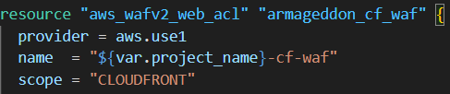
aws_wafv2_web_acl: Creates a WAFv2 Web ACL.
armageddon_cf_waf: Terraform’s local name for referencing it elsewhere.
provider = aws.use1: Uses your us-east-1 provider alias.
✅ This is required for CloudFront WAF because CloudFront’s WAF resources must be created in us-east-1.
name: Names the Web ACL using your project name.
scope = "CLOUDFRONT": This ACL is for CloudFront (not for an ALB/API Gateway, which would be REGIONAL).
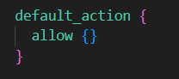
If a request doesn’t match any blocking rule, it is allowed.
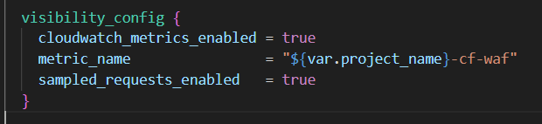
cloudwatch_metrics_enabled = true: Publishes WAF metrics to CloudWatch.
metric_name: The CloudWatch metric namespace/name for this ACL.
sampled_requests_enabled = true: WAF stores a sample of requests for inspection/troubleshooting (useful in the console under “Sampled requests”).

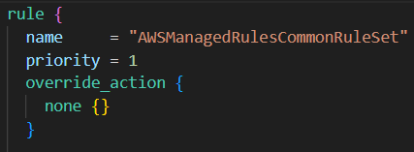
Adds one rule to this ACL:
- AWSManagedRulesCommonRuleSet is a prebuilt AWS-managed group that covers common web threats (typical things like bad bots patterns, suspicious request patterns, generic L7 attacks, etc.).
priority = 1: Rule evaluation order. Lower number runs earlier. With only one rule, it’s basically “first”.
- For managed rule groups, override_action controls how Terraform applies the group’s internal actions.
- none {} means: don’t override—let the managed rule group use its default actions (typically block/allow depending on the rule inside the group).
If you used count {} here instead, it would put the rule group into “count mode” (log matches but don’t block), which is common during testing.

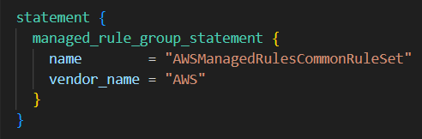
This is the “match logic.”
You’re telling WAF: “Use AWS’s managed rule group named AWSManagedRulesCommonRuleSet.”

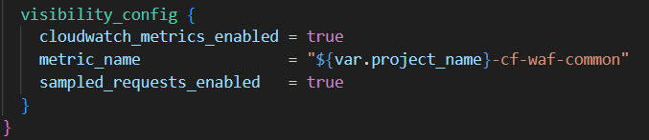
Same idea as the ACL-level config, but for this specific rule:
- Separate CloudWatch metrics and sampled request tracking for just this rule group.

